|  |
| --- |
| **The water cycle**  Key questions:   1. What are the processes in the water cycle? 2. What influences water flows and the availability of water in different places? |

**ACTIVITY: Diagrams**

It may be surprising to learn that there are people who would get offended if you mislabelled a map, infographic, illustration or computer graphics as a diagram.

Diagrams are different from these in a few key ways:

* Generally, diagrams do not show numerical data (only ideas and relationships)
* They tend to use shapes rather than real world pictures, and lines and arrows to show the relationships between the ideas

1. 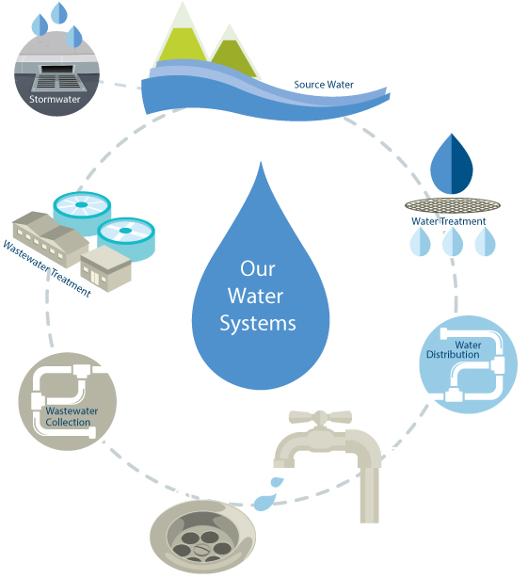Look at the two sources below. Decide which is the better example of a true diagram.

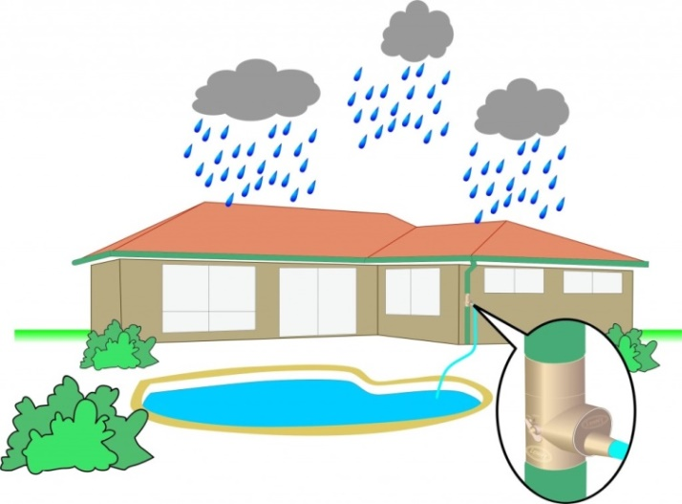

1. Listen to your teacher describe the water cycle and try and draw it as a diagram in the space below. <https://www.theweek.in/news/sci-tech/2019/06/14/New-diagrams-depict-an-alternate-view-of-how-humans-impact-water-cycle.html>

Remember to use shapes e.g. circles for ideas, and lines or arrows to show a relationship or movement.

|  |  |  |  |  |
| --- | --- | --- | --- | --- |
| watecycletitle | | | | |
| Fill in the blanks below with words from this box: | | | | |
| * evaporation * evaporates * heating * droplets * runoff * rain | * sunny * clouds * heavy * plants * snow * rivers | | * precipitate * vapor * oceans * hail * cycle * streams | * condenses * atmosphere * lakes * glaciers * crystals |
| **Evaporation**  On a warm, _________ day, water in a glass of water seems to slowly disappear. This is because the energy from the sun is ____________ the water up and turning the liquid water into water ___________. This process is called evaporation. When the water _________________, it becomes an invisible gas in the ________________. Evaporation takes places all over the earth, but especially in the ___________ and ______________ where there is lots of water. Condensation As the water vapor rises, it cools off and _______________ into water _____________. If the water vapor becomes extremely cold, it will form ice ______________ instead of water droplets. As the water droplets or ice crystals grow bigger and more numerous, they form ______________. Precipitation If water droplets or ice crystals become too ____________, they can’t stay in the air. They _________________. Water droplets precipitate as __________ and ice crystals precipitate as ____________. Sometimes, the rain freezes before it hits the earth and precipitates as _______________. | | | | |
| rain4 | | Runoff This precipitation gathers into _____________ and ______________ that flow down to the lakes and oceans. This is called _____________. Not all of the water makes it back to the oceans and lakes right away. Some of it is used by animals and _____________. Some is frozen into ______________. Eventually, the animals and plants breathe the water out and the glaciers melt, releasing the water back into the water ______________.  © 2006 www.bogglesworldesl.com | | |

**ACTIVITY:** The following diagram of the water cycle is missing the key geographic terminology. Use the word bank below to annotate the diagram so that it reflects correct terminology.

|  |
| --- |
| **Precipitation Condensation Runoff Evaporation** |

